# Technical Communication Assessment

The assignment will take approximately 1.5 to 2 hours to complete. There are 6 questions for 5 marks each. The total marks are 30.

## Enter your Name and Email Address

Puneet Suresh Khamborkar

khamborkarpunit@gmail.com

## Question 1 *(5 marks)*

Study the below screenshot and write the steps to uninstall 7-Zip from the computer.

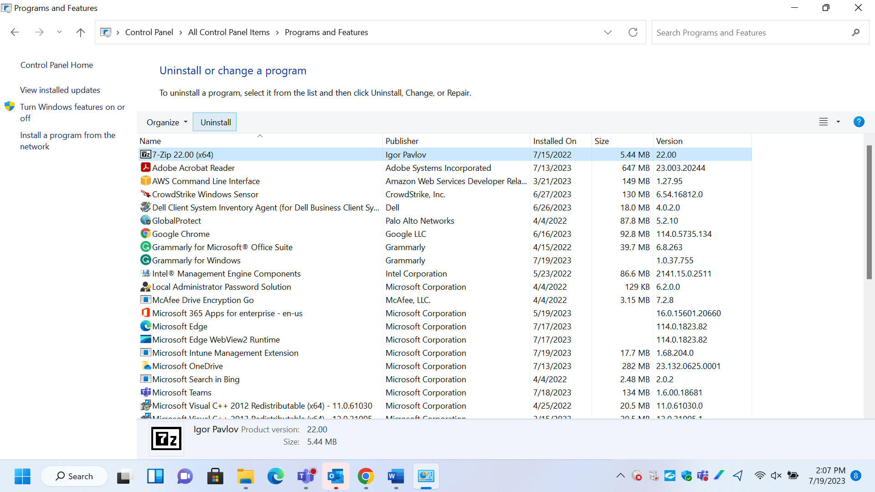

Steps to uninstall 7-Zip from the computer

1. Enter “Control Panel” in the “Search” bar.
2. Hover the cursor over the “Control Panel” icon.
3. On the right-hand side, click on “uninstall a program” option.
4. Select the “7-Zip 22.00” option from the list of programs.
5. Click on the “Uninstall” button.
6. Wait for the program to get uninstall.
7. Restart the computer after uninstallation is completed.

## Question 2 *(5 marks)*

The following screenshots depict confusing user messages. Based on your understanding/assumption, can you simplify and rewrite the user messages?

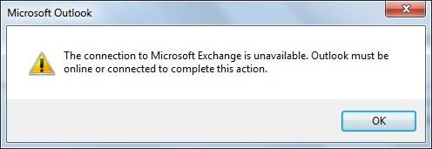

**Revised Message**:

Please ensure that you are connected to the internet to complete this action.

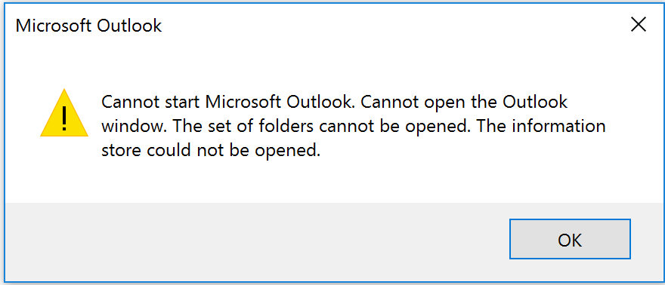

**Revised Message**:

Unable to load Microsoft Outlook, please try again later.

## Question 3 *(5 marks)*

There is a requirement from an Engineering team to document APIs for a cloud-based application. The team is unsure about the tool to document the APIs and wants the Technical Writer to suggest one. The team wants to simplify their APIs for the users. There are some unknown areas for which the Engineering team has not given much information.

As a Technical Writer, what would be your questions to the Engineering team before you start documenting?

1. How many APIs are needed to be configured?
2. What kind of operating system are they using?
3. How are the APIs getting tested?
4. What are the parameters that are needed to be addressed by the APIs?

## Question 4 *(5 marks)*

You are arranging a surprise birthday party for a colleague. Your team consists of 119 members in different locations. This will be a hybrid party. Those in town will join physically and the rest online. You have selected a team of 4 as part of Planning Committee.

Write down instructions for the Planning Committee. You will write the context and the steps the Planning Committee must take to plan and implement the event.

Colleague Birthday Party

1. **Prerequisites:**

Cake, Decoration, Snacks, Gift

All four team members would be responsible for procuring one prerequisite each.

t1 - cake

t2 - decoration

t3 - snacks

t4 - gift

1. **Event Flow:**

| **Time** | **Responsibility** | **Team Member** |
| --- | --- | --- |
| 2 pm | Sending the invitation out to all the team member over the mail | t2 |
| 5 pm | Securing an open space to celebrate the birthday | t3 |
| 5 pm | Decorating the place | t1, t2, t3, t4 |
| 6 pm | Setting up virtual communication channels for online attendees | t3, t4 |
| 6 pm | Getting the cake ready | t1 |
| 6:30 pm | Gathering the offline crowd. | t4 |
| 7 pm | Cake Cutting and Birthday Celebration | t1, t2, t3, t4 |
| 7:15 pm | Snacks Distribution | t2, t3 |
| 7;30 pm | Gift giving ceremony | t1, t2, t3, t4 |

## Question 5 *(5 marks)*

The following flow diagram depicts the software localization process.

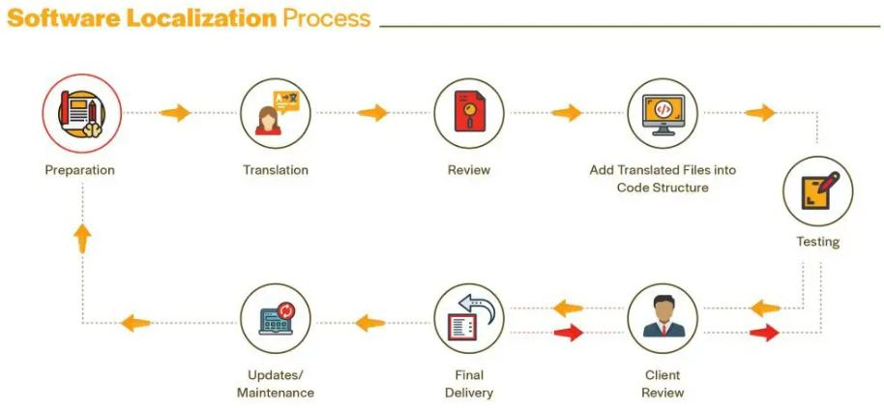

Can you explain this to a non-technical end-user in simple steps?

Yes

1. Procure the document that is needed to be localized
2. Translate the document using translation tools
3. Review the translated document
4. Add the translated content from the document into the code structure
5. Test the updated code structure
6. Submit the output to the client for review
7. Incorporate the client’s feedback in the code structure, if any
8. Submit the final output to the client
9. Incorporate last-minute feedbacks from the client, if any
10. Resubmit the final output
11. Maintain the final output until any updates are needed
12. Update the final output for newer revision
13. Prepare the revised document for the next localization process

## Question 6 *(5 marks)*

Can you describe a *(task or project, or assignment)* failure you faced during your career and how you overcame it?

In the retrospect, I have made many mistakes in the past. Transitioning from a creative writer to technical writer was a hassle for me. They were two completely different approaches towards creating content. I often forgot to restrain myself in the realms of technical writing. I would nelect the technical writing principles of applicability & content reuse and would rewrite reusable content. Slowly and with practice, I managed to get a hold of the technical writing methodology. I do not make these kind of mistakes anymore.